Notes for April 7

Binomial Expressions and Coefficients

Consider the following binomial expressions in Maple:

> f1 := (a + b)^8;
> expand(f1);
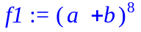
> f2 := (a + 1)^8;
> expand(f2);
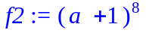

Note, both f1 and f2 have the same coefficients. The first is more general since the second can be obtained from the first by substituting in 1 for b. The Maple syntax for using the subs command to substitute a value is:

> subs(var = value, expr);

Explicitly, we could obtain f2 from f1 by

> subs(b = 1, f1);
> expand(%);
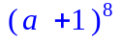
Note, more than one variable can be substituted at one time. For example,

> subs(b = 1, a = -1, f1);
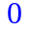
The coeffs command will pick off all of the coefficients of an expression; however, not in any particular order.

> coeffs(f1);
> coeffs(f2);
The coeff command can be used to pick of a specific coefficient. The Maple syntax for using the coeff command is:
> coeff( expr, var, order)

For example:

> coeff(f2, a, 3);
> coeff(f2, a, 7);
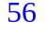
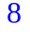
The first picks off the coefficient of 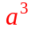 which is 56 and the second picks off the coefficient of 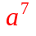 which is 8. Consider the effect of the same commands applied to f1

> coeff(f1, a, 3);
> coeff(f1, a, 7);
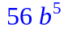
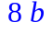
In the expansion for f1 each term is of the form 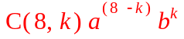 where C (8,k) is a specific number which is called the binomial coefficient which depends on both 8 and k. The 8 is there because f1 was the 8th power of the binomial (a + b). The index k determines which particular term we are looking at. In general, if we consider the binomial 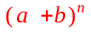 then the binomial coefficient is denoted C (n,k). Note the binomial coefficient depends on both n and k, that is, on the binomial power n and the index of the term k.

If you consider how the terms are generated when the expression 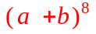is multiplied out, then it is fairly obvious in the general case why the general binomial coefficient C (n,k) is the number of ways of choosing k objects from a set of n objects. For example, when you multiply out and then collect the terms 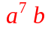 then there are exactly 8 ways the term could have arisen in the multiplication. Hence, C (8,7) = 8.

One way of determining the binomial coefficients is to have Maple expand (or 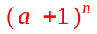 ) and then use the coeff command to pick of specific coefficients of specific terms, as demonstrated above.

A second way is to use the built-in Maple command binomial(n,k). For example, we could find the same numbers 56 and 8 (as we computed in the example above) by

> binomial(8,3);
> binomial(8,7);
A third way is to use a specific formula for computing C (n,k) in terms of factorials.

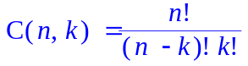
> C(8,3) = 8!/(5!*3!);
> C(8,7) = 8!/(1!*7!);

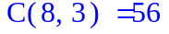
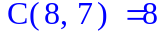

for loops vs seq statement

Consider the difference between the effect of the following two commands for displaying repetitive calculations. Both statements do the same calculations

> for n from 0 to 3 do
> binomial(3,n);
> od;
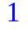
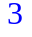
> seq(binomial(3,n),n=0..3);
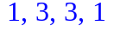
The first one writes for each value of the index (n) the value of output on a different line. When n = 0, it calculates binomial(3,0) which is 1 and writes the value; when n = 1, it calculates binomial(3,1) which is 3 and writes the value, etc.

The second one writes for each value of the index (n) the value of output on the same line. When n = 0, it calculates binomial(3,0) which is 1 and writes the value; when n = 1, it calculates binomial(3,1) which is 3 and writes the value, etc.

Standard Math vs Line Print Notation

Maple output is always displayed in what is called standard math, that is displayed so that formulas look like typeset math. Subscripts and superscripts appears as such, square root symbols and fractions signs appear as such, etc. E.g.,

> 6*a^15/y^7;
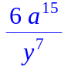
> sqrt((a*x^3));
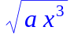

Maple input is typically entered in what is called line print notation: mathematics is displayed in a format similar to Maple commands, such that any expression is rendered on a single line without using subscripts, superscripts, or mathematical symbols. However, Maple input in line print notation can be converted to standard math and vice versa. By right clicking on a Maple input in line print notation, a dialog box is brought up which allows the you to change the line print notation to standard math or vice versa by right clicking on a Maple input in standard math, a dialog box is brought up which allows the you to change the standard math to line print notation. E.g.,

> sqrt( (1 + x^2) / (1 - x^2) );
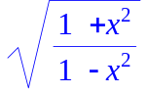
> 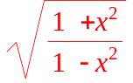

Note the input is the same in both cases and Maple computes the same output. What has changed between the two lines is the way the input is displayed.

Symbolic Expressions vs Operations

Normally we have manipulated symbolic expressions. At the start of this note, both f1 and f2 were examples of symbolic expressions (assigned to variables). As such we can algebraically manipulate them: we can multiply them, divide them, expand them, simplify them, etc. The following are other examples of symbolic expressions (in x):

> p1 := 3*x^5 - 4*x^4 + 4*x^2 - 2;
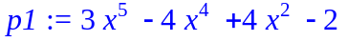
> p2 := (1 + x^2) / (1 - x^2);
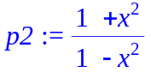
Of course, if you want to evaluate one of these expressions at a specific value you can use the subs command as described above to compute a specific value for the expression and output the value. Note the expression itself has not changed value.

> subs(x=-2, p1);
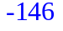
> subs(x=2, p2);
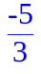
> p1;
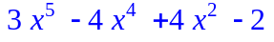
> p2;
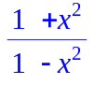

An alternate way to defined a functional relationship is to use a structure which is called an operation (in x). Consider the operations (note the syntactical difference):

> p3 := x -> 3*x^5 - 4*x^4 + 4*x^2 - 2;
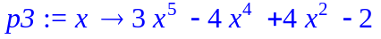
> p4 := x -> (1 + x^2) / (1 - x^2);
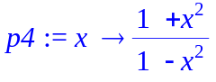
p3 and p4 are examples of operations. They behave in the same way Maple’s built-in standard operations behave. For example, to compute a value with the square root function you have to supply an argument to the square root function, e.g.

> sqrt(2);
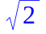
The same is true about operations such as p3 and p4

> p3(-2);
> p4(2);
Note these are the same values obtained by using the subs command to evaluate the symbolic expressions (in x) p1 and p2 at -2 and 2, resp.

The argument can be a specific number, a variable (the same x as was used to define it originally or another variable (say w or t ) or an expression. E.g.,

> p3(2);
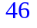

> p4(x);
> p4(w);
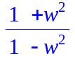
> p3(t);
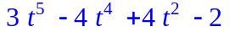
> p4(a+b);
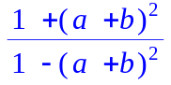

However, operations cannot be manipulated like symbolic expression by simply referring to their names. Compare:

> p1*p2;
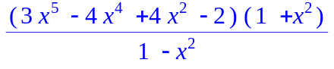
> p3*p4;
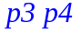

If you supply an argument to p3 and p4, then you can manipulate the value of the operation. E.g.,

> p3(x)*p4(x);
The argument can be any value, variable or expresssion. E.g.,

> p3(t)*p4(t);
